DataLake Big Data Analytics Cloud Documentation

Industry: Big Data & Analytics Platform

Case Study: 114 : DataLake Big Data Analytics Cloud

Student Details:
- Student Name: Rayan Rawat
- Cohort: Mark Zuckerberg
- Roll No: 150096724141
- Subject: AWS

Live Link:-
https://datalake-aws-project.onrender.com/

Git-Hub Link:-
https://github.com/Rayan-141/DataLake_BigData_AWS_Project

Problem Statement:-
The DataLake Big Data Analytics Cloud project addresses the challenges of managing datasets using traditional local systems. The existing system relies on local file storage, manual data management, limited monitoring, and weak security, making it difficult to manage large datasets efficiently.
The organization requires a centralized cloud platform that provides secure file storage, centralized data management, infrastructure monitoring, user access control, alerts, and a web-based dashboard accessible from anywhere.

Existing System:-

- Files are stored on local computers.
- Data is managed using spreadsheets and manual processes.
- Reports are created manually.
- There is no centralized dashboard.
- No proper monitoring of server health.
- No alert system for resource issues.
- Data sharing is done manually.
- Security is limited and cloud access control is not available.
- The local database has no centralized cloud storage.

Problems in Existing System:-

- Local File Storage: Files can be lost if the computer crashes.
- No Centralized Dashboard: Administrators cannot manage everything from one place.
- No Monitoring: CPU, Memory, Disk, and Network usage cannot be monitored.
- No Alerts: Administrators are not notified when server resources become high.
- Limited Security: No centralized user and permission management.
- Manual Dataset Management: Uploading, downloading, and managing datasets is difficult.
- Limited Accessibility: The application cannot be accessed remotely.
- Manual Deployment: Deploying the application requires manual setup on every system.

Proposed Solution:-

The proposed solution is to build a centralized DataLake Big Data Analytics Cloud Platform using AWS services and a web-based dashboard. The platform securely stores datasets, monitors infrastructure, manages users, and provides centralized access through a live cloud application.

Solution Highlights:

- Amazon S3 – Secure cloud storage for uploaded datasets.
- AWS IAM – Secure access and permission management.
- MySQL – Centralized database for users, reports, and dataset metadata.
- Amazon CloudWatch – Infrastructure monitoring (CPU, Memory, Disk, Network).
- CloudWatch Alarms – Detects high resource usage and generates alerts.
- Amazon SNS – Sends alert notifications to administrators.
- Docker – Containerized application deployment.
- GitHub – Source code management and version control.
- Render – Live cloud hosting for the web application.
- Web Dashboard – Centralized management for datasets, monitoring, reports, users, and infrastructure status.

Working Flow:- image link

⇩

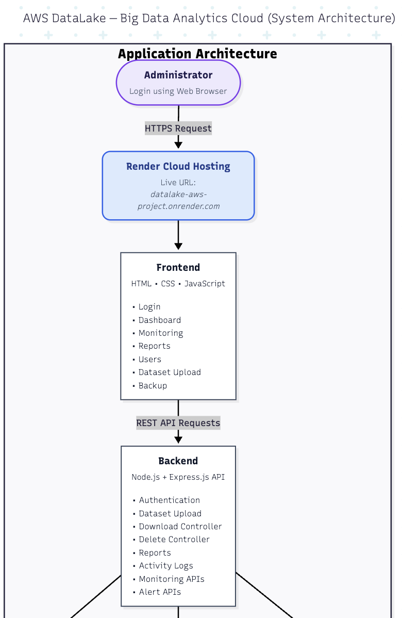
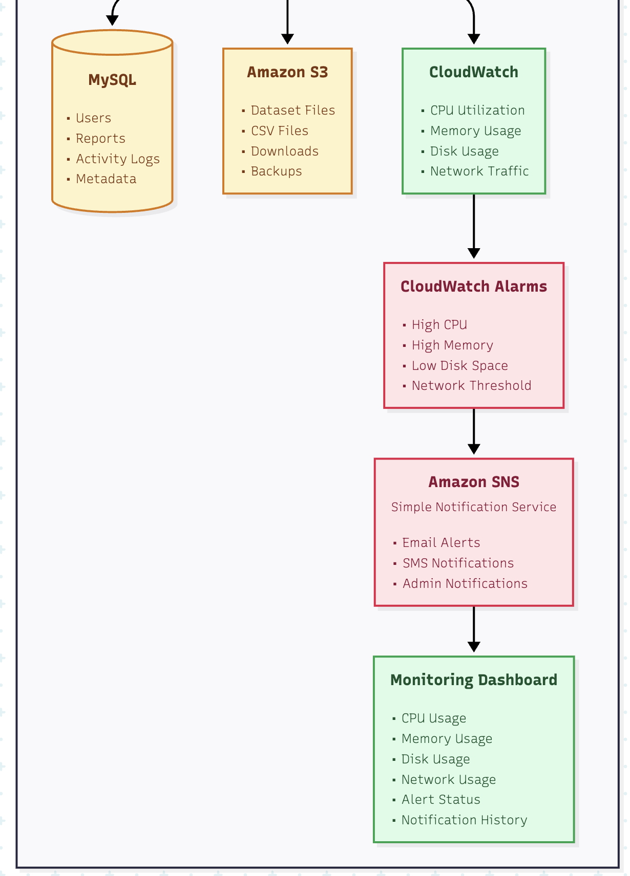

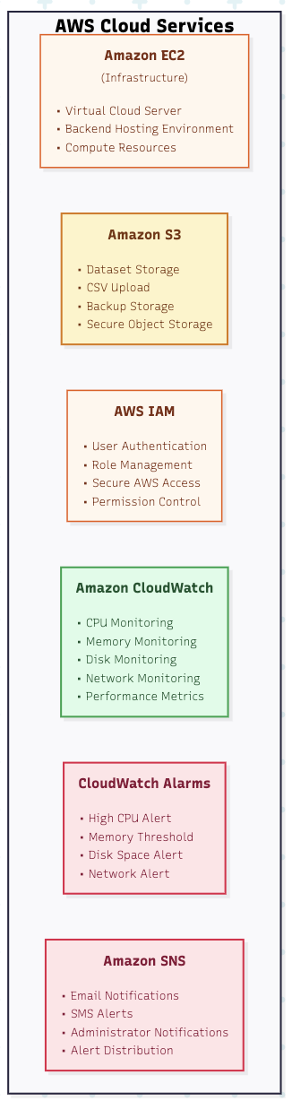
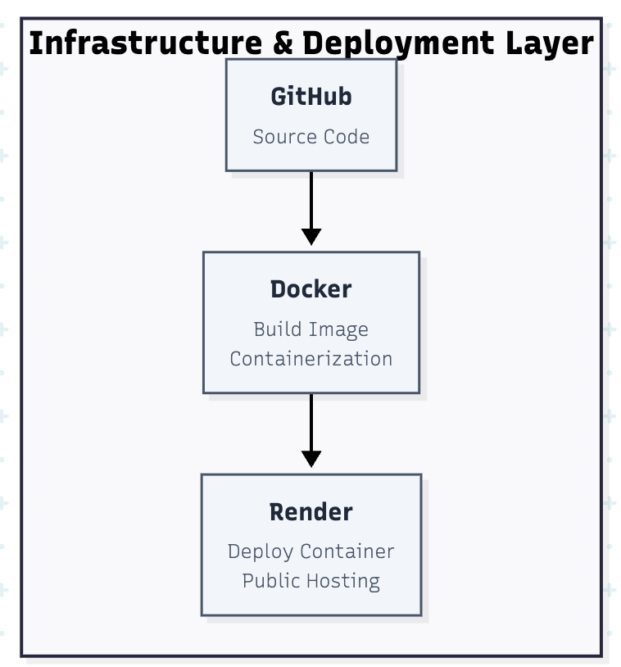

Objectives:-

- Centralized Platform: A single UI to manage all data at https://datalake-aws-project.onrender.com/
- Secure Authentication: Implementing JWT or session-based login for role-based access.
- Elastic Storage: Using S3 for scalable file management.
- Monitor: CPU, Memory, Disk, and Network utilization.
- Real-time alerts: Alerts for abnormal resource usage.

AWS Services Used:-

1. Amazon EC2 (Elastic Compute Cloud)

Why Used?
- To host the application on a cloud server.
Where Used?
- Backend server.
Purpose
- Runs the Node.js application in the cloud instead of a local machine.

2. Amazon S3 (Simple Storage Service)

Why Used?
- To store uploaded datasets.
Where Used?
- Dataset Upload section.
Purpose
- Keeps files safe, secure, and easily accessible.

3. AWS IAM (Identity & Access Management)

Why Used?
- To secure AWS resources.
Where Used?
- AWS Account.
Purpose
- Controls who can access AWS services and what actions they can perform.

4. Amazon CloudWatch (Simulated)

Why Used?
- To monitor infrastructure health.
Where Used?
- Monitoring Dashboard.
Purpose
- Shows server metrics like:
  - CPU Usage
  - Memory Usage
  - Disk Usage
  - Network Usage

5. Amazon CloudWatch Alarms

Why Used?
- To detect abnormal resource usage and trigger alerts..
Where Used?
- Monitoring & Alerting System.
Purpose
- Displays alerts when CPU, Memory, Disk, or Network usage becomes high.

5. Amazon SNS (Simple Notification Service)

Why Used?
- To send alert notifications to administrators.
Where Used?
- Alert Notification System.
Purpose
- Delivers Email Notifications , SMS Notifications , Administrator Alerts , etc

Technology Stack:

Layer | Technology
Frontend | HTML5, CSS3, JavaScript (Nginx Web Server)
Backend | Node.js, Express.js Framework
Database | MySQL (Relational)
Storage | Amazon S3
Compute | AWS EC2 (Ubuntu)
Container | Docker & Docker Hub
Control | Git & GitHub

Architecture:-

The architecture follows a standard 2-tier web pattern:

- User hits the Elastic IP (44.208.74.131).
- Nginx acts as a reverse proxy, forwarding traffic to Node.js on port 3000.
- Node.js processes logic and queries the MySQL database for records.
- S3 handles file storage via AWS SDK.
- CloudWatch monitors the EC2 instance and sends alerts via SNS.

Problem Statement vs Proposed Solution :-

Previously (Existing System) | Now (Proposed Solution)
Files were stored on local desktops. | Files are securely stored in Amazon S3.
Application depended on a single local system. | Application is hosted on a cloud server (EC2/Cloud Infrastructure).
No centralized dashboard for management. | A Web Dashboard manages datasets and monitoring from one place.
No proper monitoring of server resources. | CloudWatch monitors CPU, Memory, Disk, and Network usage.
No alert system for server issues. | CloudWatch Alarms generate alerts for resource issues.
Administrators were not notified about problems. | Amazon SNS sends alert notifications to administrators.
No secure access to cloud resources. | AWS IAM provides secure user access and permissions.
Dataset information was difficult to manage. | MySQL Database stores dataset details and application data.
Deployment was manual and time-consuming. | Docker simplifies application deployment.
Application could not be accessed from anywhere. | Render hosts the application with a live public URL.

Problem → Solution Flow:-

Local File Storage
│
▼
Amazon S3 Storage
────────────────────────────
No Monitoring
│
▼
CloudWatch Monitoring
────────────────────────────
No Alerts
│
▼
CloudWatch Alarms
────────────────────────────
No Notifications
│
▼
Amazon SNS
────────────────────────────
No Secure Access
│
▼
AWS IAM
────────────────────────────
No Central Dashboard
│
▼
Web Dashboard
────────────────────────────
Manual Deployment
│
▼
Docker + Render
────────────────────────────
Scattered Data
│
▼
MySQL Database

Limitations:-

- Uses MySQL instead of Amazon RDS.
- CloudWatch metrics are simulated for demonstration.
- CloudWatch Alarms and Amazon SNS are implemented as project concepts, not full real-time integration.
- Does not include Auto Scaling or Load Balancer.
- Supports a single-region deployment only.
- Advanced enterprise security features are not implemented.

Conclusion:-

The DataLake Big Data Analytics Cloud project provides a secure and centralized cloud platform for managing datasets. It uses Amazon S3 for storage, AWS IAM for security, CloudWatch for monitoring, CloudWatch Alarms and Amazon SNS for alerting concepts, and Docker and Render for deployment. The project improves data storage, monitoring, security, and accessibility, while providing a strong foundation for future cloud enhancements.

